Supplementary material

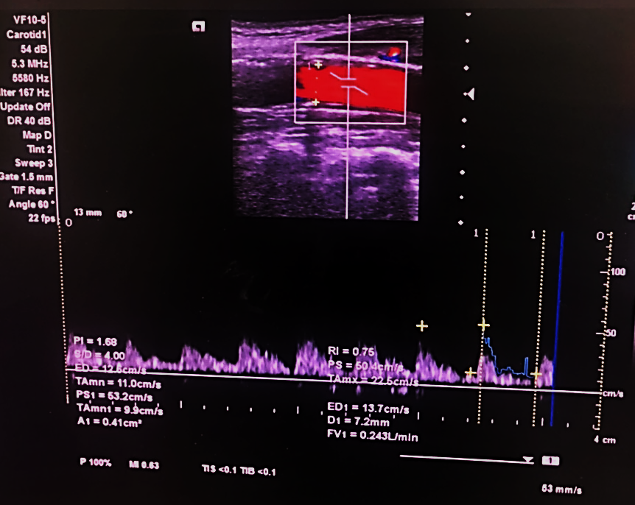
Supplementary Fig. 1. A screenshot of the internal carotid artery flowmeasurement on Doppler sonography. PI, pulsatility index; RI, resistance index; S/D, systolic/diastolic; PS, peak systolic; ED, end diastolic; TAmx, time-averaged maximum velocity; TAmn, time-averaged minimum velocity; D, vessel diameter; A, area; FV, flow volume.

