Supplementary material

Supplementary data Retrieval strategies for the electronic databases
Pubmed:
((opioid free anesthesia) OR (opioid free)) AND (((laparoscopy) OR (laparoscopic)) OR (laparoscopic surgery))
Embase:
#1 opioid AND free AND anesthesia OR (opioid AND free)
#2 laparoscopy OR laparoscopic OR (laparoscopic AND surgery)
#3 #1 AND #2
Cochrane library:
#1 opioid AND free AND anesthesia OR (opioid AND free)
#2 laparoscopy OR laparoscopic OR (laparoscopic AND surgery)
#3 #1 AND #2
Web of science:
#1 (ALL = (opioid free anesthesia)) OR ALL = (opioid free)
#2 ((ALL = (laparoscopy)) OR ALL = (laparoscopic)) AND ALL = (laparoscopic surgery)
#3 #1 AND #2

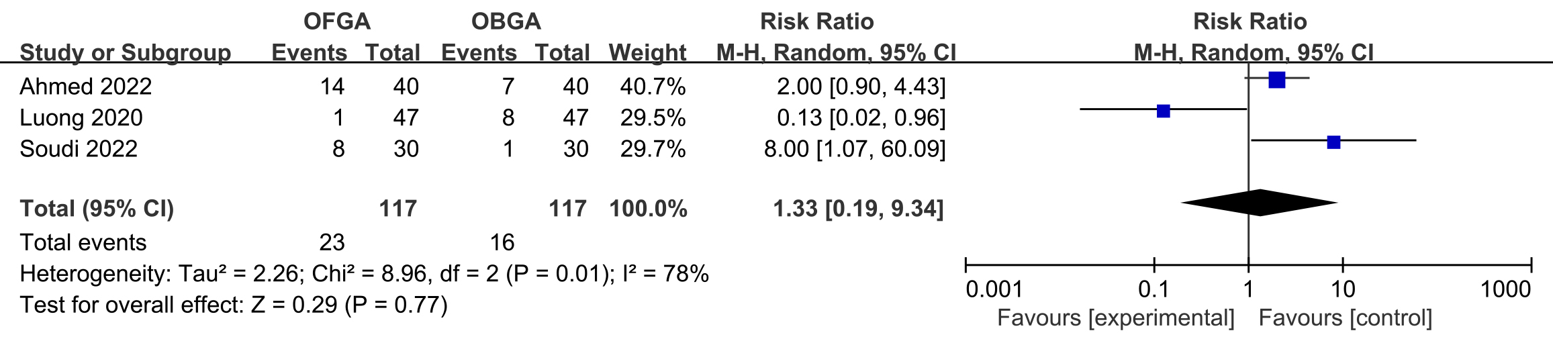
Supplementary Fig. 1. Forest plot of hypertension incidence. OFGA: opioid free general anesthesia; OBGA: opioid-based general anesthesia; CI: confidence interval.

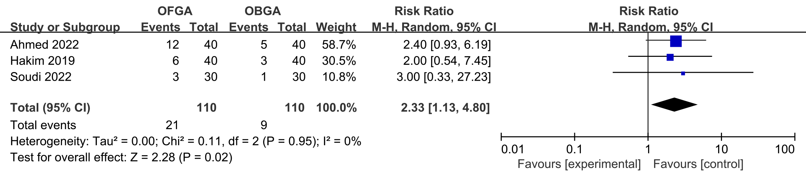
Supplementary Fig. 2. Forest plot of bradycardia incidence. OFGA: opioid free general anesthesia; OBGA: opioid-based general anesthesia; CI: confidence interval.

