Supplementary material

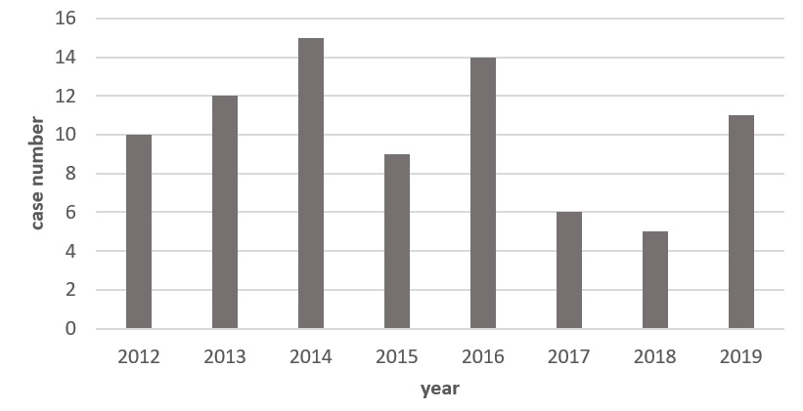
Supplementary Fig. 1. Distribution of MP cases over the years.

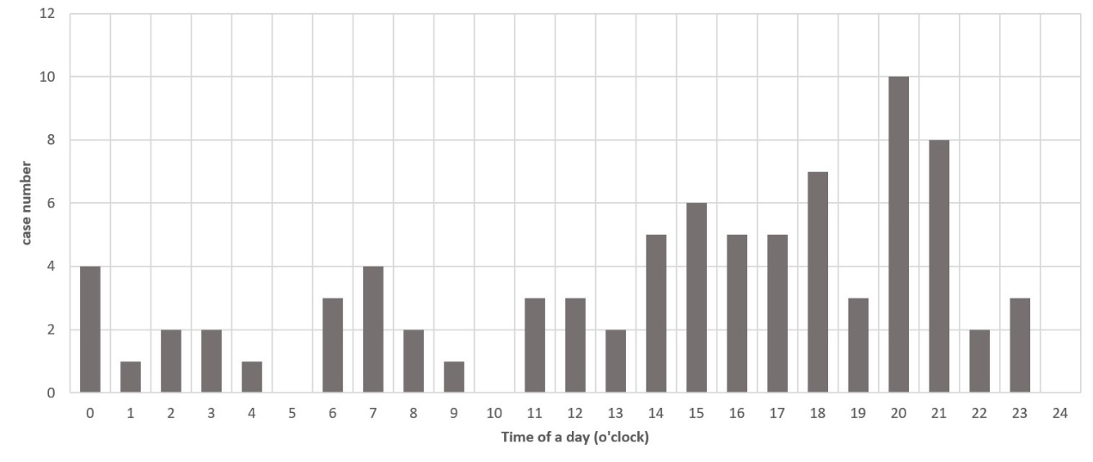
Supplementary Fig. 2. Arrival times of cases with MP to the emergency department.

