Supplementary material

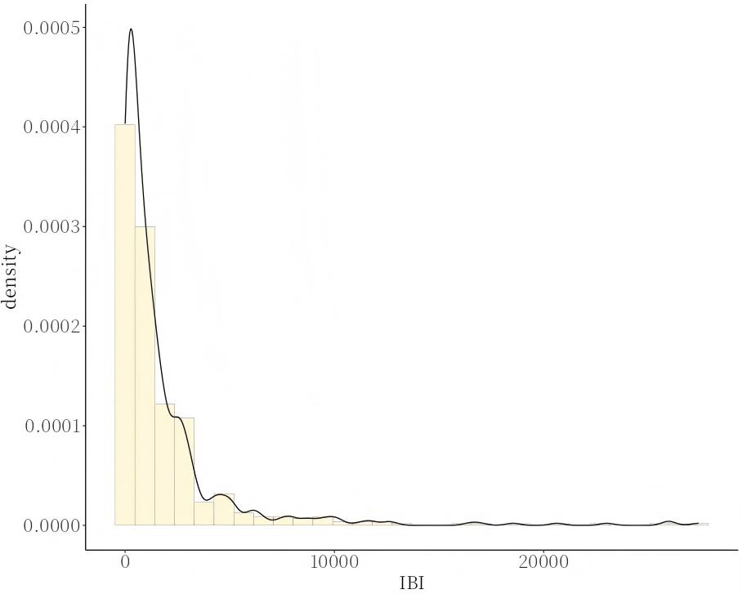
Supplementary Fig. 1. Histogram of IBI. IBI, inflammatory burden index.

Supplementary Table 1. Missing number (%) for included variables in dataset.
Variables | Missing (%)
Weight (kg) | 7 (1.1%)
WBC (K/μL) | 10 (1.6%)
PLT (K/μL) | 14 (2.3%)
Hemoglobin (g/L) | 15 (2.4%)
RDW (%) | 16 (2.6%)
AG (mmol/L) | 27 (4.4%)
Serum sodium (mg/dL) | 21 (3.4%)
PT (s) | 35 (5.8%)
PTT (s) | 37 (6.1%)
WBC, white blood cell; PLT, platelet; RDW, red cell distribution width; AG, anion gap; PT, prothrombin time; PTT, partial thromboplastin time.

Supplementary Table 2. Baseline characteristics of included and excluded patients.
Variables |  | Included group  (n = 600) | Excluded group  (n = 11,734) | p-value
Gender
 | Male | 342 (57.00) | 6595 (56.20) | 0.70
 | Female | 258 (43.00) | 5139 (43.80) | 0.70
Age at admission(years) |  | 71.00 (62.00, 80.00) | 75.00 (65.00, 84.00) | <0.001
Race
 | White | 341 (56.83) | 8010 (68.26) | <0.001
 | Other | 259 (43.17) | 3724 (31.74) | <0.001
Hypertension, n (%) |  | 51 (8.50) | 3164 (26.96) | <0.001
Diabetes, n (%) |  | 145 (24.17) | 1890 (16.11) | <0.001
SOFA |  | 5.00 (3.00, 8.00) | 5.00 (3.00, 7.00) | 0.06
APS Ⅲ |  | 48.00 (37.00, 62.00) | 45.00 (35.00, 57.00) | <0.001
SAPS Ⅱ |  | 39.50 (33.00, 48.25) | 39.00 (31.00, 47.00) | 0.039
OASIS |  | 33.00 (28.00, 39.00) | 32.00 (27.00, 38.00) | 0.025
GCS |  | 15.00 (14.00, 15.00) | 15.00 (14.00, 15.00) | 0.50
CCI |  | 7.00 (5.00, 9.00) | 7.00 (5.00, 9.00) | 0.22
28-day mortality after ICU admission |  | 103 (17.17) | 2064 (17.59) | 0.79
28-day in-hospital mortality |  | 96 (16.00) | 1995 (17.00) | 0.52
In-ICU mortality |  | 56 (9.33) | 1041 (8.87) | 0.69
In-hospital mortality |  | 105 (17.50) | 1612 (13.74) | 0.009
ICU, intensive care unit; SOFA, sequential organ failure assessment; APS, acute physiology score; SAPS, simplified acute physiology score; OASIS, oxford acute severity of illness score; GCS, Glasgow coma scale; CCI, Charlson comorbidity index.

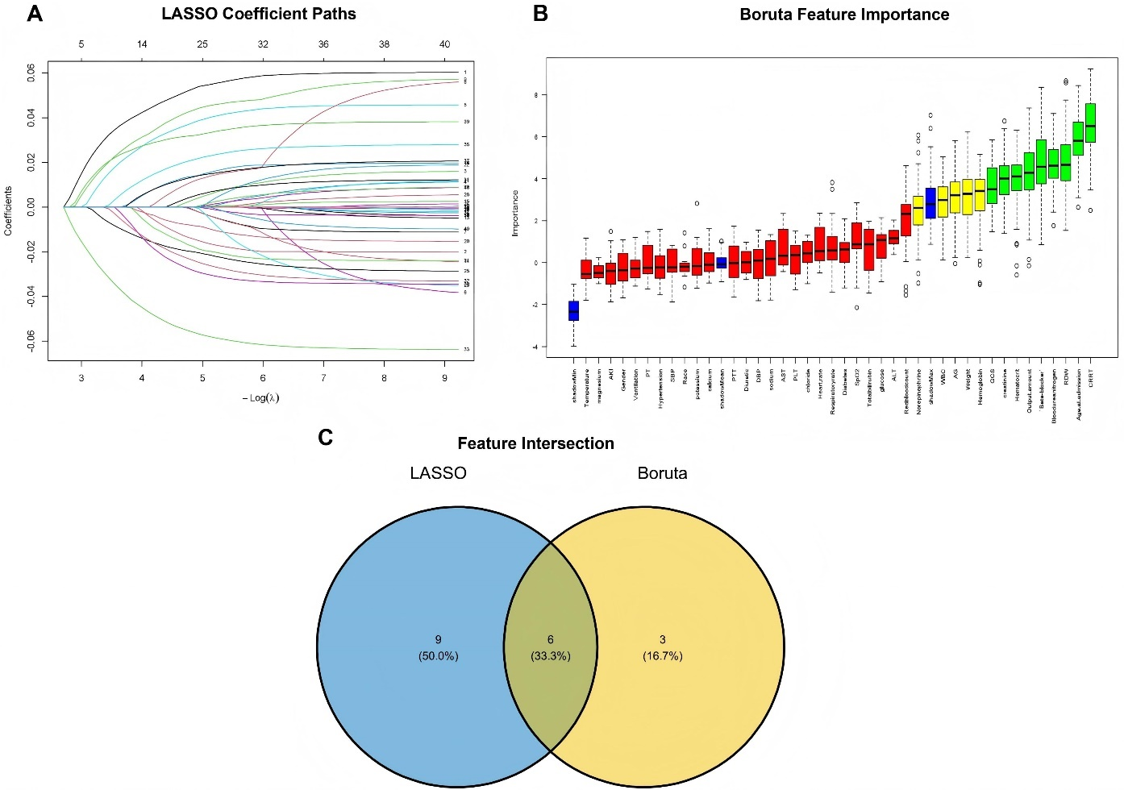
Supplementary Fig. 2. Flowchart of the covariate selection process. (A) LASSO coefficient paths showing the trajectory of variable coefficients across different log(λ) values. (B) Boruta feature importance plot displaying the importance scores of all variables. (C) Venn diagram illustrating the intersection of features selected by LASSO and Boruta algorithms. (1) To mitigate potential multicollinearity, composite clinical scoring systems—including SOFA, APS III, SAPS II, OASIS, and CCI—were excluded from the initial feature selection, as these indices are derived from overlapping physiological parameters. The GCS was retained as an independent predictor. Consequently, a total of 43 candidate variables were incorporated into the Least Absolute Shrinkage and Selection Operator (LASSO) regression and the Boruta algorithm for feature screening. (2) LASSO regression identified 15 candidate predictors, while the Boruta algorithm identified 9. The intersection of these two methods yielded six robust covariates for the final model. (3) The final selected variables were: age at admission, RDW, output amount, GCS score, beta-blocker use, CRRT. SOFA, Sequential Organ Failure Assessment; APS III, Acute Physiology Score III; SAPS II, Simplified Acute Physiology Score II; OASIS, Oxford Acute Severity of Illness Score; CCI, Charlson Comorbidity Index; GCS, Glasgow Coma Scale; RDW, Red Cell Distribution Width; CRRT, Continuous Renal Replacement Therapy; LASSO, Least Absolute Shrinkage and Selection Operator; AKI, acute kidney injury; PT, prothrombin time; SBP, systolic blood pressure; PTT, partial thromboplastin time; DBP, diastolic blood pressure; AST, aspartate aminotransferase; PLT, platelet; SpO₂, pulse oxygen saturation; ALT, alanine aminotransferase; WBC, white blood cell; AG, anion gap.

Supplementary Table 3. The variance inflation factor test.
Variable | VIF
Output amount | 1.129
Age at admission | 1.125
CRRT | 1.064
GCS | 1.040
RDW | 1.023
Beta-blocker | 1.021
GCS, Glasgow Coma Scale; RDW, Red Cell Distribution Width; CRRT, Continuous Renal Replacement Therapy; VIF, variance inflation factor.

Supplementary Table 4. Incremental AUC analyses.
Variable |  | AUC_Variable | AUC_LnIBI | Diff_AUC (95% CI) | p value
28-day mortality after ICU admission
 | CRP | 0.595 | 0.643 | 0.0048 (0.004, 0.092) | 0.032
 | Neutrophil counts | 0.574 | 0.643 | 0.069 (−0.011, 0.147) | 0.06
 | Lymphocyte counts | 0.599 | 0.643 | 0.044 (−0.012, 0.104) | 0.14
In-ICU mortality
 | CRP | 0.592 | 0.645 | 0.053 (0.0060, 0.103) | 0.047
 | Neutrophil counts | 0.610 | 0.645 | 0.035 (−0.053, 0.124) | 0.44
 | Lymphocyte counts | 0.589 | 0.645 | 0.056 (−0.023, 0.136) | 0.19
CRP, C-reactive protein; AUC, Area Under Curve; LnIBI, log-transformed Inflammatory Burden Index; CI, confidence interval; ICU, intensive care unit; Diff, difference.

